**SMART E UNIFORM FOR SOLDIERS USING IOT**

**ABSTRACT**

Soldiers, who courageously defend our nation, face diverse weather conditions during their service. To safeguard them, a climate-adjustable smart E-uniform has been developed. This innovative uniform dynamically adjusts to provide warmth or cooling, depending on the prevailing weather conditions. The uniform operates in two modes: summer and winter, allowing soldiers to regulate their body temperature as needed. Key components of the uniform include a temperature sensor, a microcontroller, a power supply, and heating/cooling mechanisms. The temperature sensor continuously monitors the soldier's body temperature, while the microcontroller analysis this data to activate the appropriate heating or cooling devices as required.

**INTRODUCTION**

Soldiers, the backbone of our nation's defence, endure various challenges, especially adverse weather conditions, while safeguarding our country. The Solar E-Uniform for Soldiers project designed to harvest solar energy to power communication and health monitoring devices, has shown promise in increasing soldiers' endurance and safety in isolated environments.

However, extreme battlefield conditions demand not just energy autonomy but intelligent sensing and active protection mechanisms needed. Environmental hazards such as toxic gases, intense heat, and unforeseen obstacles remain serious threats. Moreover, traditional solar-powered uniforms lacked adaptive cooling technologies crucial for extreme climates, it suffered from several critical limitations: dependency on sunlight, reduced efficiency in cloudy or indoor conditions, added weight due to solar panels, and lack of active thermal control mechanisms.

To overcome these shortcomings, this project introduces a Smart E-Uniform for Soldiers enhanced with real-time environmental sensing, thermal management, and IoT-based visualization with removal of solar panel replaced by reusable batteries. By incorporating ultrasonic sensors for obstacle detection, gas sensors for chemical threat identification, temperature sensor for climate control, and Peltier cooling modules managed by IoT control through “Thing Speak”, this uniform serves not only as a shield but as a smart assistant for soldiers on the field.

**EXISTING SYSTEM:**

The Solar-Based E-Uniform project is an early prototype designed to help soldiers monitor their body or environmental temperature using IoT technology. In this system, the uniform is equipped with: Arduino Uno R3 microcontroller (as the central control unit), temperature sensor (commonly DHT11 or LM35) and solar panel (to supply power to the Arduino and sensor). It works on the solar panel charges a battery or powers the system directly then temperature sensor collects real-time data about the soldier’s body or surrounding temperature. At last Arduino Uno reads this data and sends it to LCD display received data.

**DISADVANTAGES OF EXISTING SYSTEM:**

* Arduino UNO R3 version microcontroller doesn’t have built-in Wi-Fi module for send automatic alerts.
* Solar panels are ineffective during night operations indoors, or in low-light/bad weather conditions.
* It does not provide any active cooling or heating; it only monitors temperature without improving soldier comfort.
* Solar panels can add weight and stiffness to the uniform, reducing soldier mobility and comfort.

**PROPOSED SYSTEM**

The proposed system is a **smart embedded wearable module** designed for soldiers operating in extreme and hazardous environments. It integrates **environmental monitoring,** **personal safety control,** and **automated thermal regulation** using a combination of sensors and actuators powered by **ESP8266** and controlled remotely via **IoT connectivity**.

**1. Toxic Gas Detection**

* The Gas sensor continuously monitors for the presence of harmful gases (e.g., CO, methane, LPG).
* When toxic gas is detected beyond a safe threshold, the system:
  + Sends an alert to a remote server via Wi-Fi using ESP8266.

**2. Proximity & Obstacle Monitoring**

* An Ultrasonicsensor is embedded to detect nearby objects or moving threats.
* Useful for:
  + Detecting environmental obstructions or potential hazards.
  + Enhancing safety during operations in low visibility or confined areas.

**3. Dynamic Body Temperature Regulation**

* A Peltiermodule is used to heat or cool the soldier’s uniform based on surrounding temperature conditions.
* Controlled by the ESP8266 via a relaymodule.
* Automatically activates when ambient conditions exceed comfort thresholds.

**4. Smart Cooling with Fan Control**

* A DC fan assists in cooling during overheating scenarios, activated based on:
  + High ambient temperature.
  + High body temperature.

**5. IoT Connectivity (ESP8266)**

* Sends real-time data (temperature, gas levels, obstacle distance) to a clouddashboard.
* Enables remotemonitoring by commanders or control units.
* Can be integrated with platforms like ThingSpeak.

**ADVANTAGE OF EXISTING SYSTEM:**

* It uses Node MCU ESP 8266 Microcontroller it has built-in Wi-Fi with high processing power than Arduino.
* Allow commanders to monitor soldier’s environment and health via Think Speak
* Components like fans and Peltier modules are activities only when needed, saving energy and improve battery life.
* Combines health monitoring, environmental sensing and smart control in one compact system.
* Alerts and automation reduce manual checks and help soldiers stay on focussed on their mission.

**BLOCK DIAGRAM**

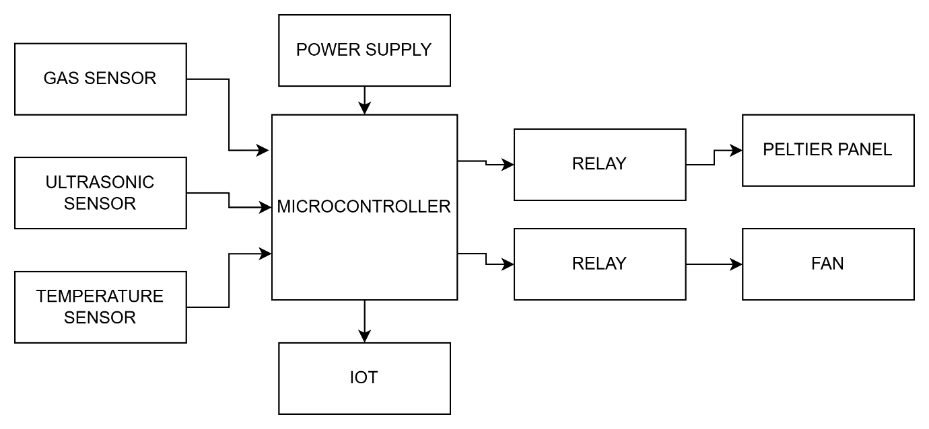

**HARDWARE REQUIREMENTS**

Microcontroller

Ultrasonic sensor

Gas sensor

Temperature sensor

Peltier panel

Fan

Relay

LCD

Batteries

**SOFTWARE REQUIREMENTS**

Arduino IDE

Think speak (Data visualization)

**CONCLUSION**

The proposed smart E-uniform for soldiers using IOT offers a practical and innovative solution for enhancing soldier safety, comfort, and operational efficiency in hazardous environments. By integrating key components such as a gas sensor, ultrasonic sensor, ESP8266, relay module, cooling fan, and a Peltier panel, the system is capable of real-time monitoring, environmental adaptation, and wireless data transmission.

This smart embedded system not only detects harmful gases and nearby obstacles but also autonomously regulates body temperature based on environmental conditions. The use of IoT through the ESP8266 enables remote monitoring, early warnings, and proactive decision-making from command units.

Overall, this project demonstrates the effective application of embedded systems and IoT in defence technology, ensuring improved survivability, situational awareness, and mission readiness for soldiers in extreme and life-threatening conditions.